Design

Navabar(logo can be changed if there is something good):



Hero section:

Content:

Welcome to Piano Lessons with Miriyam, where the keys unlock boundless musical potential. At Piano Lessons with Miriyam, our vision transcends traditional learning, aiming to elevate each student's piano skills to new heights. Through tailored instruction, passionate mentorship, and a focus on individual growth, we foster a deep love and mastery of the piano. Join us on this harmonious journey towards realizing your fullest musical expression.

Inspiration for hero:

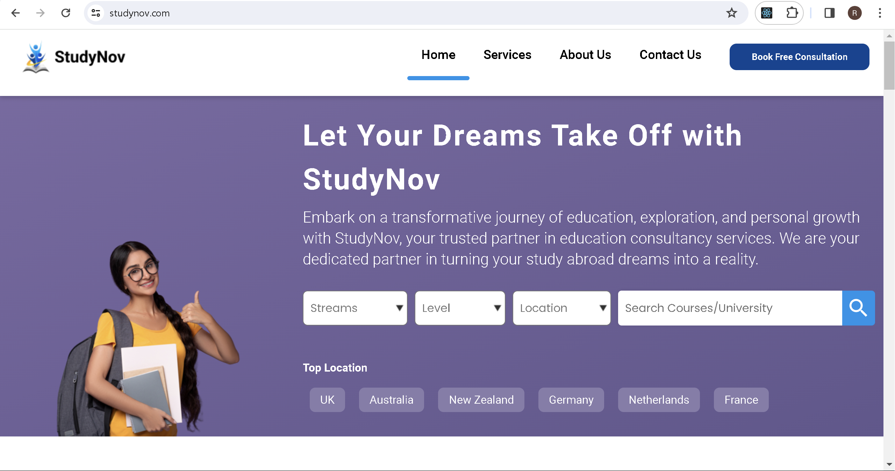

Section 2 (similar to this can be used according to content provided):

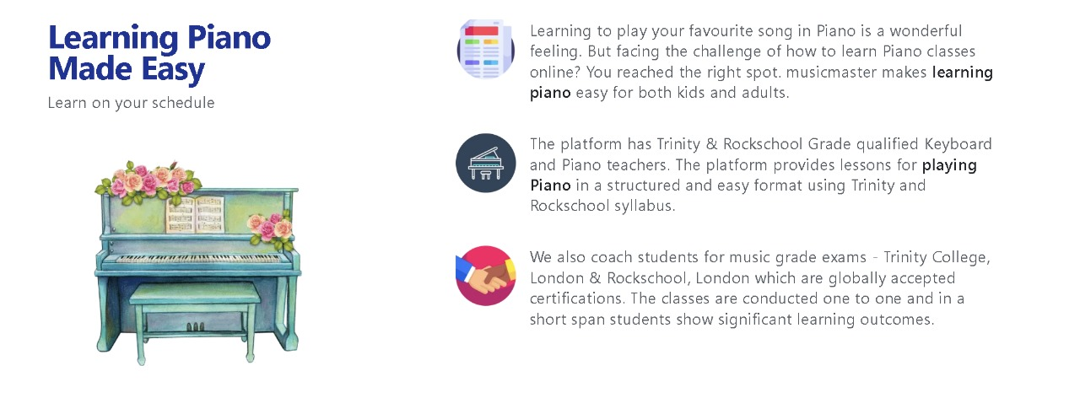

Fee structure:(some card can be used ,a card which can be rotated if it suits the design)

Reviews (static reviews for now) :

Faq(accordion):

Footer

Page2 (About us):

Content:

**About the Instructor**

Meet Miriyam: Elevating Piano Skills with a Passion for Music  
  
For over a decade, Miriyam has harmonized the melodies of devotion as a dedicated church organist, infusing spiritual serenity into congregational gatherings for the past 13 years. With an extensive musical background spanning six grades of Trinity music grade certification, Miriyam possesses an enriching wealth of knowledge and expertise in the realm of piano mastery.  
  
Beyond mastering the keys of the organ, Miriyam is fervently passionate about imparting the art of piano playing to young minds eager to explore the realm of musical expression. This passion is not merely about teaching notes and scales but instilling a deeper appreciation for the nuances of music and the joy of creating melodies that resonate with the soul.  
  
With a teaching philosophy that intertwines technical proficiency and emotional connection to music, Miriyam aspires to nurture a new generation of pianists, guiding them toward unlocking their potential and discovering the sheer delight in mastering the piano keys.  
  
In Miriyam's classes, students not only learn to play the piano but also imbibe a sense of discipline, dedication, and an unyielding passion for the art form. By creating a nurturing environment, Miriyam encourages young talents to explore their musical inclinations while providing the necessary guidance and mentorship to flourish.  
  
As Miriyam embarks on this musical journey with budding pianists, the focus remains steadfast on honing skills, nurturing creativity, and fostering a lifelong love for music that transcends the mere technicalities of playing an instrument.  
  
Join Miriyam in exploring the enchanting world of music, where every keystroke holds the potential to weave tales of emotion, harmony, and inspiration.

Inspiration: <https://studynov.com/aboutus>

Page 3: Contact us

Use your own design

Will provide with the content ,just add mobile number ,email,and Instagram,facebook